Name ___________________
Latitude lines are going across the grid (or globe). They run East and West, but they are North or South of the equator which is your zero point. Longitude are lines going down the page. They run North and South but are East of West of the prime meridian in Greenwich England which is the zero point.
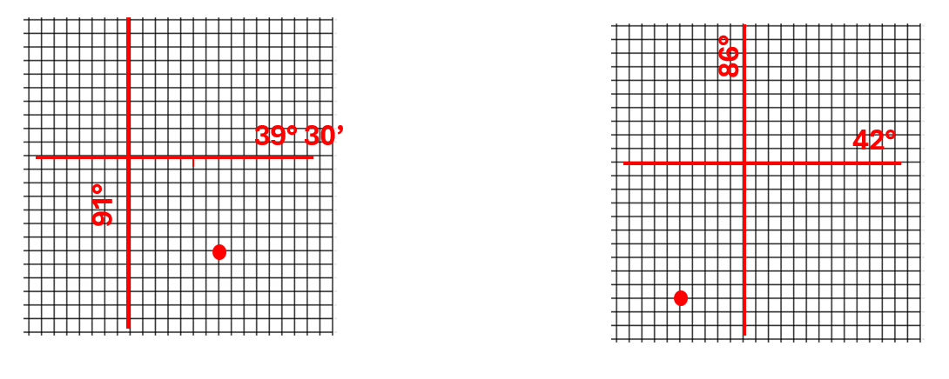 N 39° 23’ W 90° 53’ N 41° 50’ W 86° 5’
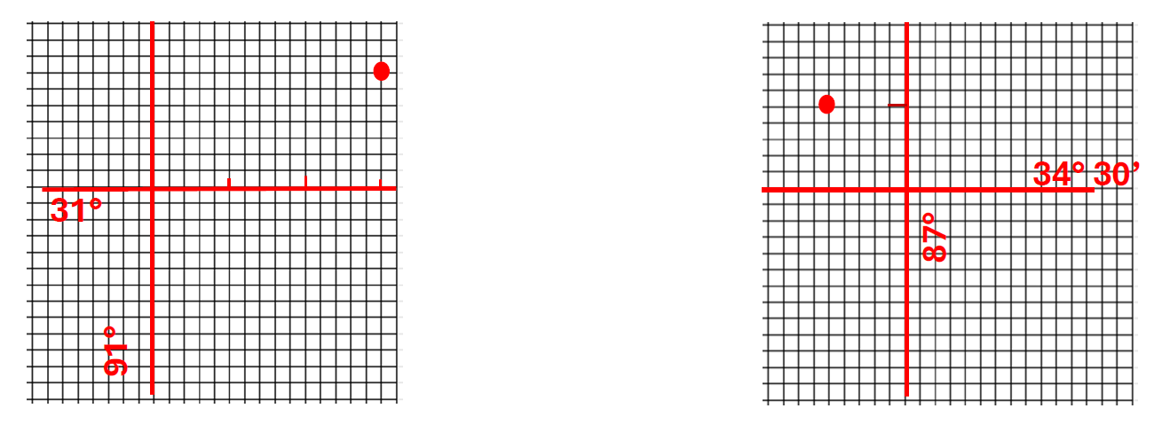
N 31° 7’ W 90° 45’ N 34° 35’ W 87° 5’
Convert the decimal to Degrees and Minutes
N 49.4517 60 X .4517= 27’ à 49° 27’
W 73.3398 60 X .3398= 20’ à 73° 20’

N 44.5923 60 X .5923= 35’ à44° 35’
W 82.5976 60 X .5976= 36’à 82° 36’

